INTRODUCTION TO TYPESCRIPT
What is TypeScript?
- TypeScript is a programming language developed by Microsoft
- TypeScript is a statically typed superset of JavaScript, meaning that it adds static types to JavaScript, along with some other features
Key Characteristics of TypeScript
- Statically Typed –
  - Unlike JavaScript, where types are determined at runtime, TypeScript allows you to specify types for variables, functions, and objects.
  - This helps catch errors at compile time rather than during execution.
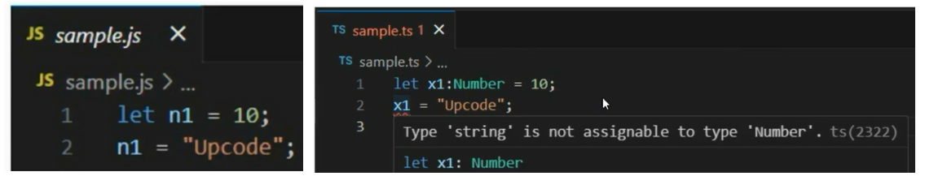
- Superset of JavaScript –
  - All JavaScript features work in TypeScript, plus additional features like types, interfaces, and generics.
- Better Code Maintainability –
  - Since TypeScript provides type safety, it helps in writing cleaner and more maintainable code, especially in large projects.
- Enhanced Developer Experience –
  - TypeScript offers better IDE support with features like auto-completion, IntelliSense, and refactoring tools.
- Compiles to JavaScript –
  - TypeScript code is compiled into standard JavaScript, which can be executed in browsers and Node.js.
Where we can use it?
TypeScript’s popularity increasing day by day. Its used
- In Angular as default programming language
- NextJs supports TS and many companies are following this approach
- NestJs, a backend framework uses TS
- ReactJS supports TS
- and many more
Many companies instruct to use TS instead of JS.
How to install?
- Install node by downloading from portal
- To check if TypeScript is installed on your system->Open Command Prompt and run command
Official TypeScript Website
Visit https://www.typescriptlang.org/ , maintained by Microsoft, for documentation, tutorials, and an online TypeScript Playground.
What can you find on the website?
- Documentation 📖 – Learn TypeScript from beginner to advanced levels.
- Playground 🏗️ – Try out TypeScript code online without installation.
- Installation Guide ⚙️ – Steps to install and set up TypeScript.
- Handbook & Tutorials 📚 – Learn TypeScript concepts like types, interfaces, generics, etc.
- Latest Updates 🚀 – Get new TypeScript releases, features, and improvements.
To get started : Create a folder –
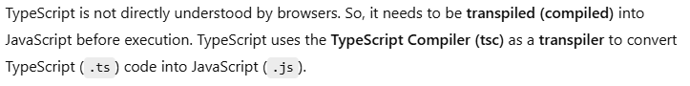
Now create a file : sample.ts
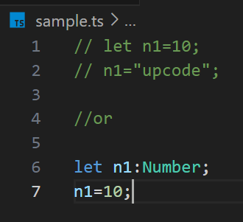
Transpile sample.ts to JavaScript :Run
This will generate a sample.js file in the same directory. Run the Transpiled JavaScript File :
History of ECMAScript (ES)
- ECMAScript (ES) is the standard that defines JavaScript.
- It is maintained by ECMA International under the TC39 (Technical Committee 39).
- The first version was released in 1997, and since then, ECMAScript has undergone several revisions, introducing new features and improvements.
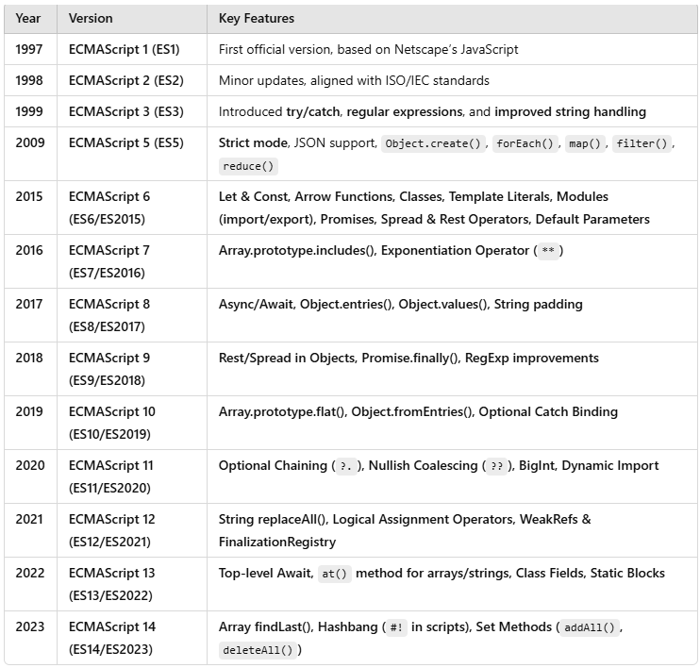

- ECMAScript (ES) is the official standard for JavaScript
- Modern web browsers implement ECMAScript versions to support JavaScript features.
- However, not all ECMAScript features are immediately supported by all browsers, which is why developers often use TypeScript to ensure compatibility.
- Different versions of ECMAScript have different levels of browser support.
- Older versions (ES3, ES5) are fully supported in all browsers, but newer versions (ES6+) may not work in older browsers without transpilation.
- TypeScript ensures that the code is transpiled into older versions for better browser compatibility.

Initialize typescript project, tsconfig file, any data type

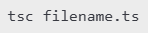
Why Use tsconfig.json?
In a project with multiple TypeScript files, manually compiling each file using:
is not feasible. Instead, we can use:
This creates a tsconfig.json file, which helps manage TypeScript compilation settings efficiently.
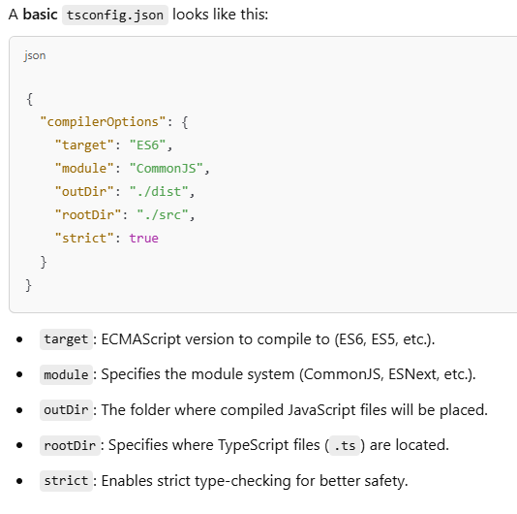
Create a file – index.ts
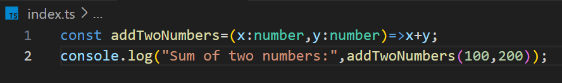
To see the difference in the generated JavaScript file when changing the TypeScript compilation target, follow these steps:
- Instead of compiling each file manually, simply run - tsc : converts all .ts files to .js files
- This will generate an index.js file.
- Open it, and you will see the function in arrow function notation (ES6 syntax).
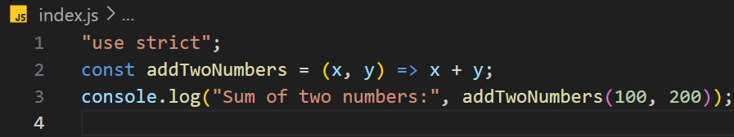
- Open tsconfig.json, locate the "target" option, and modify it to:
- Now, run: tsc
- Open the newly generated index.js file.
- Now, the arrow function will be converted to a normal function syntax, as ES5 does not support arrow functions.
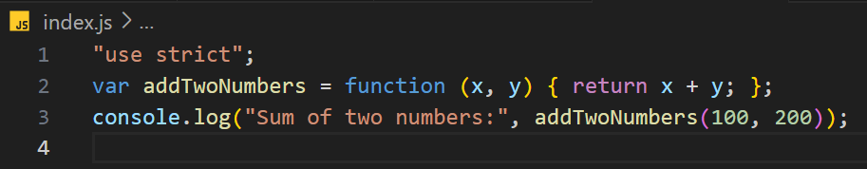
- When we compile a TypeScript file (index.ts), the generated JavaScript code depends on the "target" setting in tsconfig.json.
- This demonstrates how TypeScript allows us to control the output JavaScript version for better browser compatibility.
Watch Mode in TypeScript: tsc -w
- The tsc -w command enables watch mode in TypeScript.
- This means that once executed, TypeScript will continuously watch for changes in your .ts files and automatically recompile them whenever you make updates.
- Any changes you make in .ts files will be instantly compiled into .js files.
any Data Type in TypeScript
- The any type in TypeScript allows a variable to hold values of any type.
- It essentially turns off type checking for that variable, making it similar to JavaScript's dynamic typing.
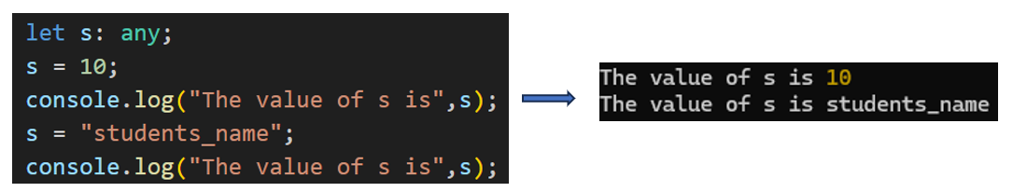
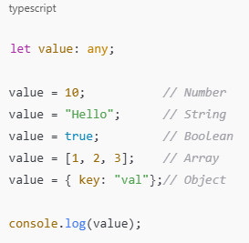
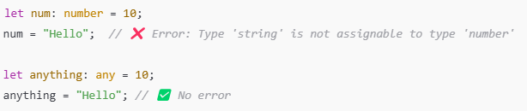
Implicit and Explicit Typing in TypeScript
1. Implicit Typing
- TypeScript infers the type based on the assigned value.
- No need to explicitly declare the type.
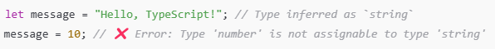
Explicit Typing
- The type is explicitly declared while defining a variable or function.
- Improves readability and ensures strict type enforcement.
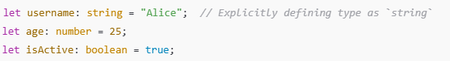
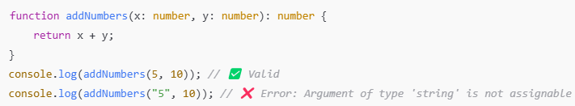
noImplicitAny in TypeScript
- The noImplicitAny option in TypeScript ensures that all variables, function parameters, and return types must have an explicitly declared or inferred type.
- If a type is not explicitly provided and TypeScript cannot infer it, an error will be thrown instead of assuming the any type.
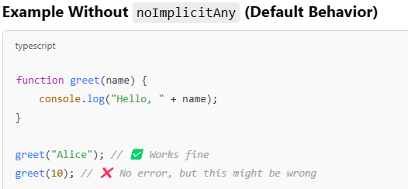

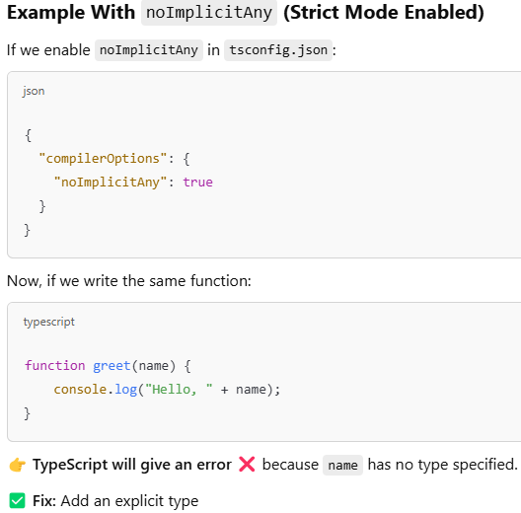
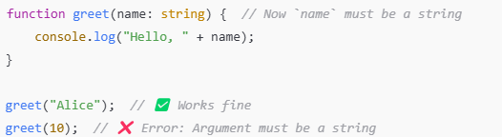
What Happens When noImplicitAny: false?
If you set "noImplicitAny": false in your tsconfig.json, TypeScript allows variables and function parameters to have an implicit any type, meaning TypeScript will not enforce explicit type annotations.
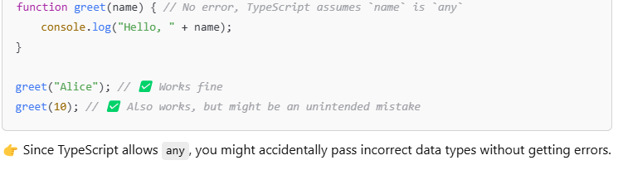
Basic data types number, string, Boolean and arrays
- In TypeScript, basic data types include number, string, boolean, and array.
- TypeScript provides static typing, ensuring type safety at compile time.

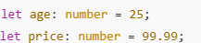
1. Number (number)
Represents both integer and floating-point numbers.

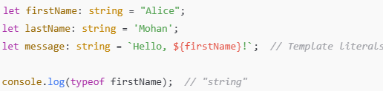
2. String (string)
Represents text enclosed in single ('), double ("), or backticks (``).

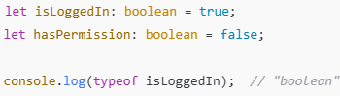
3. Boolean (boolean)
Represents true or false values.

4. Array
Stores multiple values of the same type.
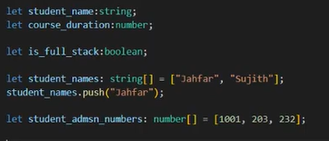
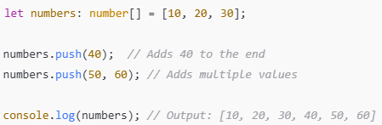

Inferred typing and duck typing
1. Inferred Typing (Type Inference)
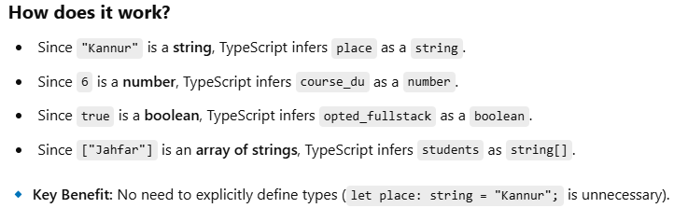
👉TypeScript automatically determines the variable's type based on the value assigned.
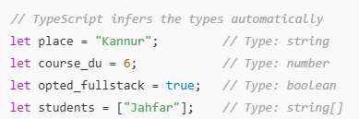

2. Duck Typing (Structural Typing)
👉 An object is considered valid as long as it has the required structure, even if it has extra properties.
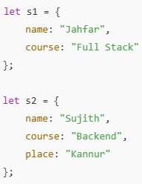 If we try to assign s1 = s2, TypeScript allows it because of duck typing (structural typing).
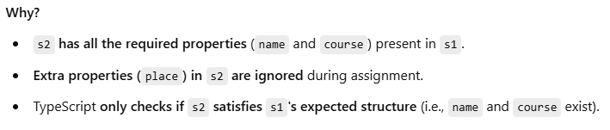
But What If We Assign s2 = s1?
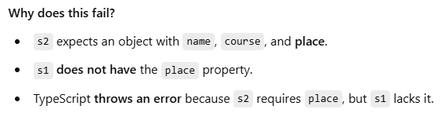

Function return types
The general syntax for defining function return types in TypeScript:
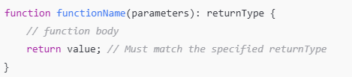
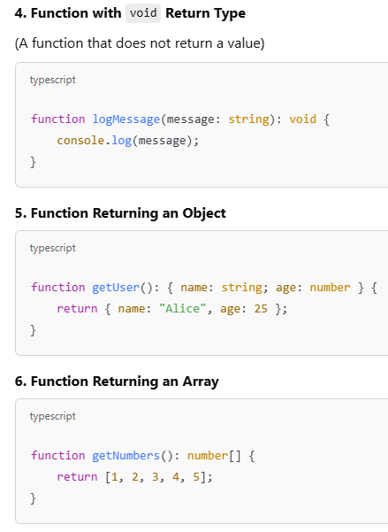
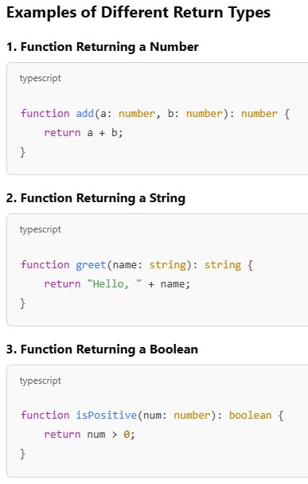
Enabling sourcemap
- When developers write code in TypeScript, it gets compiled into JavaScript, which is the code that actually runs in browsers or Node.js.
- This process makes direct debugging of TypeScript code difficult because we don’t see how TypeScript is transformed into JavaScript.
- There is no direct mapping between .ts and .js files by default, making it challenging to trace errors back to the original TypeScript code.
Solution: Enable Source Maps
Source maps create a link between the original TypeScript file and the generated JavaScript file. This allows developers to:
- Debug TypeScript code directly in the browser or an editor.
- Set breakpoints in .ts files and see the original TypeScript code during debugging.
- Get error messages that point to the exact TypeScript source instead of the compiled JavaScript.

How to Enable Source Maps
- To generate source maps, follow these steps:

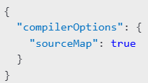
Step 1: Update tsconfig.json
Modify your tsconfig.json file to include:
Step 2: Compile TypeScript
Run the TypeScript compiler:
tsc
This will generate:
- file.js (JavaScript output)
- file.js.map (Source map file)
Step 3: Debugging in Chrome DevTools
If running the script in the browser:
- Open Developer Tools (F12 or Ctrl+Shift+I).
- Go to the Sources tab.
- You'll see the original .ts files instead of .js (because of source maps).
- Set breakpoints in .ts and debug as if running TypeScript directly!
Summary
- TypeScript compiles to JavaScript, making direct debugging difficult.
- Source maps allow mapping .ts to .js, making TypeScript debuggable.
- Enable source maps using "sourceMap": true in tsconfig.json.
- Debug TypeScript code in Chrome DevTools or Node.js with --enable-source-maps.
By enabling source maps, developers can efficiently debug their TypeScript applications without struggling with JavaScript transformations.

Creating custom data-type using 'type' and marking fields as optional
What is a Custom Data Type?
- In TypeScript, we can define custom data types using the type keyword.
- This allows us to create structured types with predefined properties, making code more readable and maintainable.
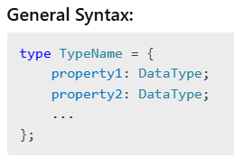
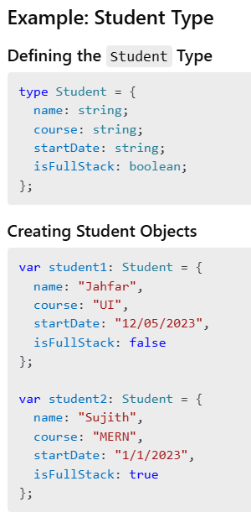
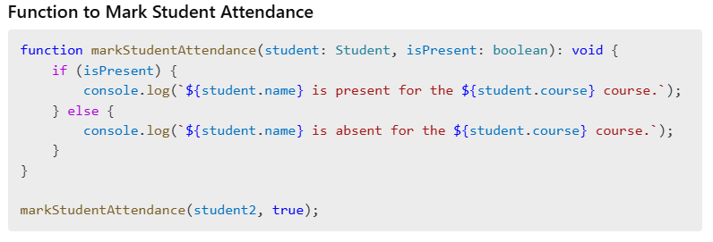
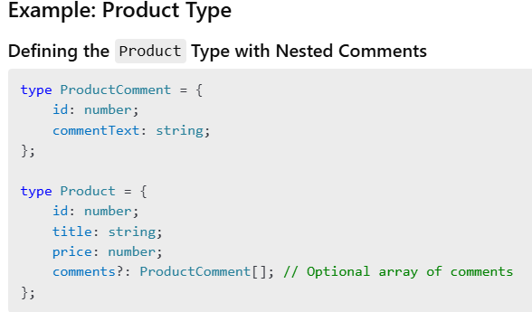
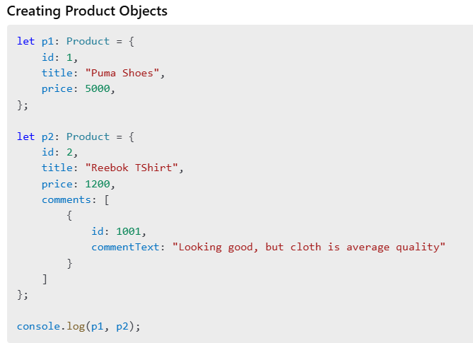
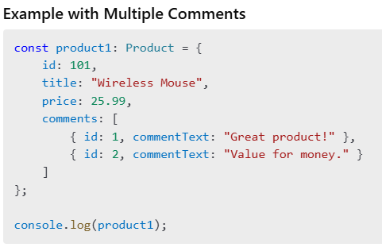
Optional Fields in TypeScript
- In TypeScript, optional fields are denoted using the ? operator.
- This means that the field may or may not be present in an object.
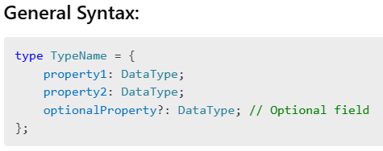
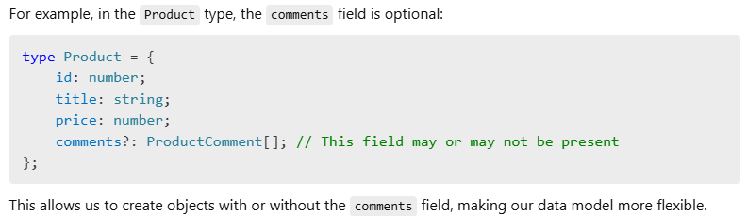
Installing a Third-Party Package in TypeScript & Its Type Declaration
- In TypeScript, third-party JavaScript libraries can be installed and used, but since they are originally written in JavaScript, TypeScript does not automatically recognize their types.
- To ensure type safety, we need to install type definitions separately if they are not built-in.
Installing a Third-Party Package
- To install any third-party package in a TypeScript project, follow these steps:

Step 1: Initialize a TypeScript Project
- If you haven't already initialized a TypeScript project, create one using
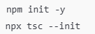
This will generate a package.json and tsconfig.json file.
Step 2: Install the Third-Party Package
For example, installing inquirer (a command-line input library):
Installing Type Declarations
- Since inquirer is a JavaScript library, TypeScript does not recognize its types automatically.
- To add type support, install the corresponding type definitions:
Why Type Declarations Are Needed?
- JavaScript libraries do not include TypeScript type information by default.
- Type declarations provide autocomplete, type checking, and error prevention.
- If a package has built-in TypeScript support (like axios or lodash-es), no extra installation is needed.

Example: Using inquirer in TypeScript

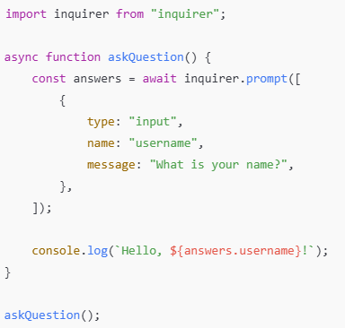

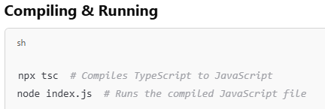
Introduction to object oriented programming
- Object-Oriented Programming (OOP) is a programming paradigm that is based on the concept of objects.
- Object-Oriented Programming (OOP) is a programming paradigm that models real-world entities as objects.
- These objects contain data (attributes/properties) and behaviors (methods/functions), similar to how things work in real life.

Connecting OOP to the Real World:
Imagine a car 🚗 in the real world:
- Class: A blueprint for creating objects (e.g., "Car" is a class).
- Object: A specific car (e.g., "Toyota Corolla" is an object of the "Car" class).
- Attributes (Properties): Color, engine type, fuel capacity.
- Methods (Behaviors): Start(), Stop(), Accelerate().

OOP Mapping for Course
- Class: Course
- Attributes (Properties):
  - ID (Unique identifier for the course)
  - Title (Name of the course)
  - Duration (Length of the course)
  - Skills (Skills taught in the course)
- Methods (Functions that operate on Course objects):
  - AddStudent() → Adds a student to the course
  - RemoveStudent() → Removes a student from the course
  - AddSkill() → Adds a new skill to the course
OOP Mapping for Dog
- Class: Dog
- Attributes (Properties):
  - Color (Color of the dog)
  - Height (Height of the dog)
  - Weight (Weight of the dog)
  - Breed (Breed of the dog)
- Methods (Actions performed by Dog):
  - Run() → The dog runs
  - Walk() → The dog walks
  - Bark() → The dog barks

The main Object-Oriented Programming (OOP) concepts are:
- Class – A blueprint for creating objects.
- Object – An instance of a class with state and behavior.
- Encapsulation – Hiding data and restricting direct access to it.
- Abstraction – Hiding complex implementation details and exposing only necessary parts.
- Inheritance – Allowing a class to derive properties and behavior from another class.
- Polymorphism – Allowing methods to have different implementations based on the object.
Here is a list of programming languages that support Object-Oriented Programming (OOP) concepts:

- Java
- C++
- C#
- Python
- TypeScript
- JavaScript
- Ruby
- Swift
- Kotlin
- PHP
- Objective-C
- Dart

Classes, Object and Construction Function
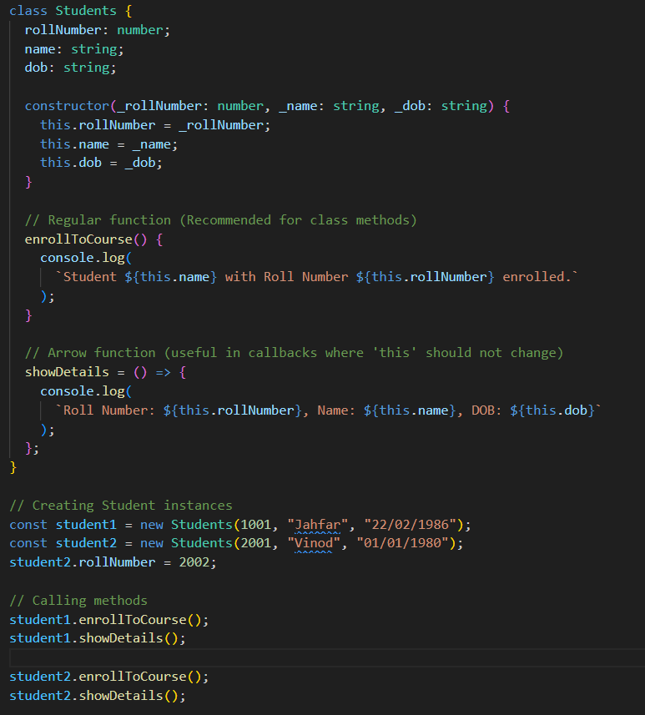

Inheritance in object oriented programming

- Inheritance is a fundamental concept in OOP that allows a class (child class) to inherit properties and methods from another class (parent class).
- This promotes code reusability and hierarchical relationships between classes.
Without Inheritance
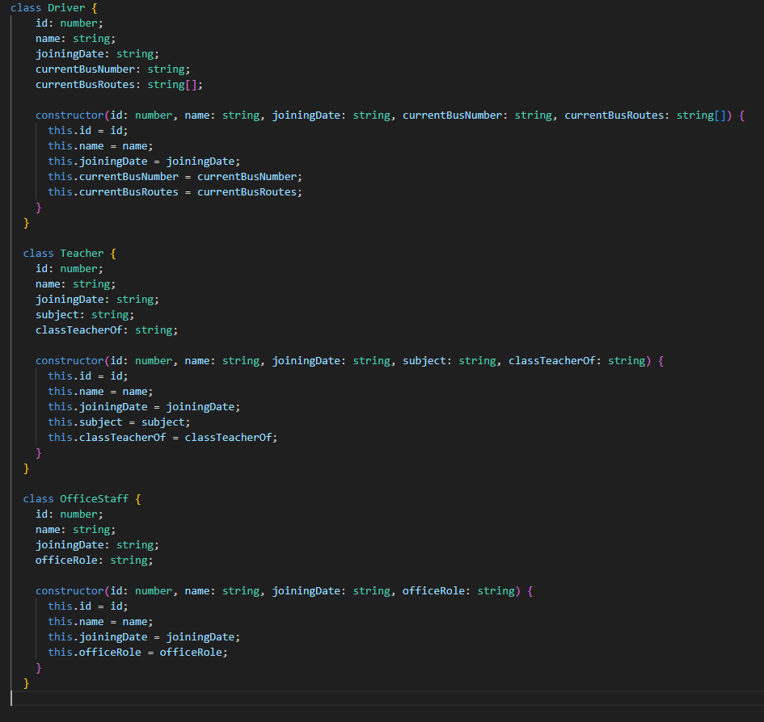

Problems:
- The same properties (id, name, joiningDate) are repeated in all classes.
- If we want to add more shared properties (e.g., phone), we must update all classes.
With Inheritance
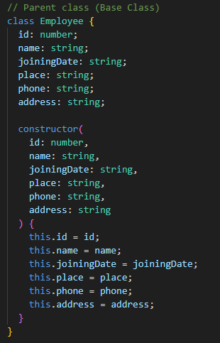

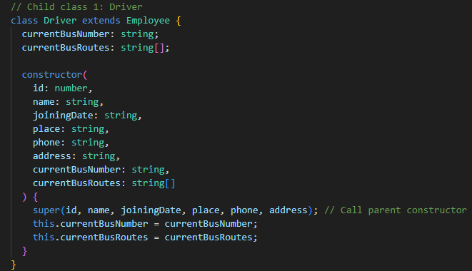

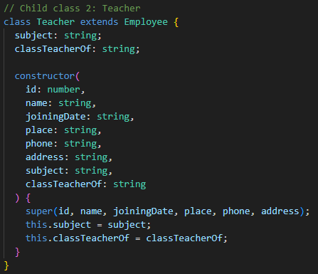

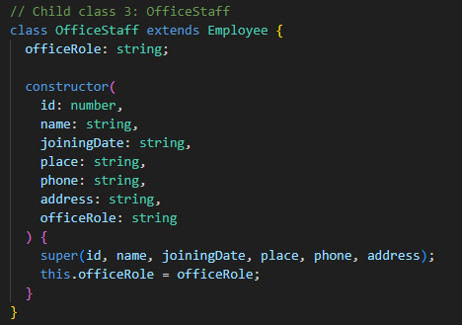

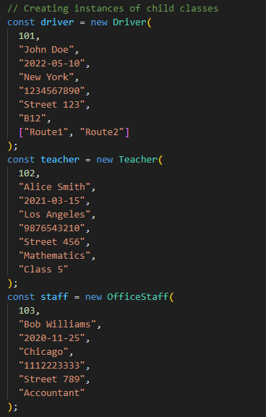

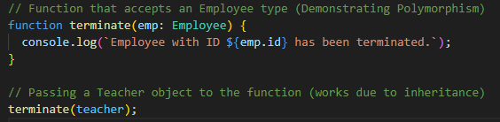

Instance-of, read-only, static properties and methods
instanceof Operator
The instanceof operator checks whether an object is an instance of a particular class or constructor function.
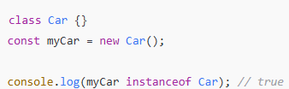
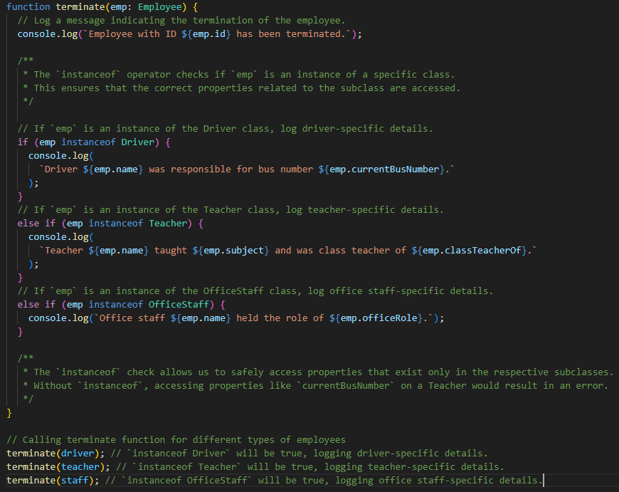
Read-Only Properties
- A read-only property is a property that cannot be modified after it is initially set.
- In TypeScript, you can define read-only properties using the readonly keyword.
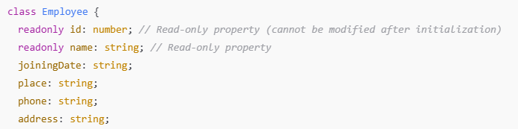

Static Properties and Methods
- Static properties and methods belong to the class itself, not to instances of the class.
- You access them directly using the class name.
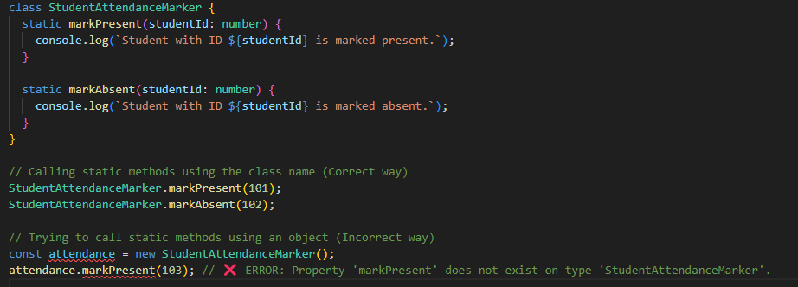
Access Modifiers in TypeScript
Access modifiers in TypeScript control the visibility and accessibility of class members (properties and methods).
1. public Modifier
- A property or method declared as public can be accessed from anywhere, including outside the class.
- By default, all class members in TypeScript are public.
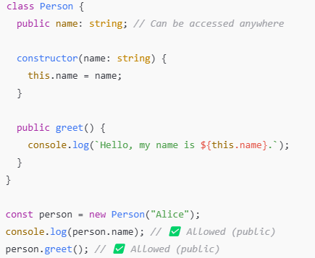

2. private Modifier
- A property or method declared as private can only be accessed inside the class.
- It cannot be accessed from outside the class or in child classes.
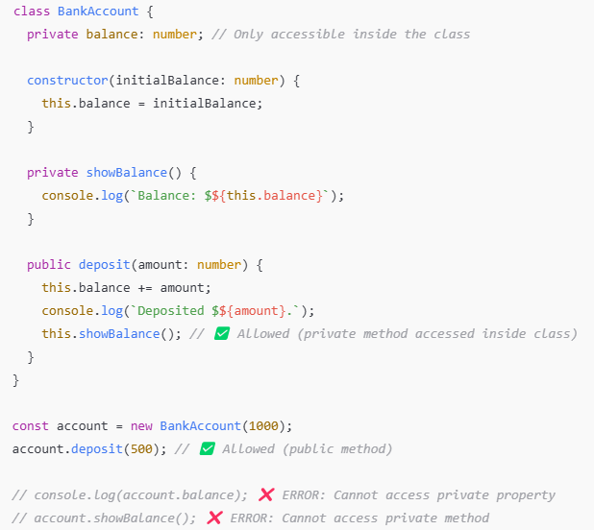

Getter and Setter Functions in TypeScript
Getters (get) and Setters (set) are special methods in a class that allow controlled access to private properties.
1. Getter (get)
- Used to retrieve the value of a private property.
- It acts like a property but is actually a function.
2. Setter (set)
- Used to modify the value of a private property.
- It allows validation before assigning a value.
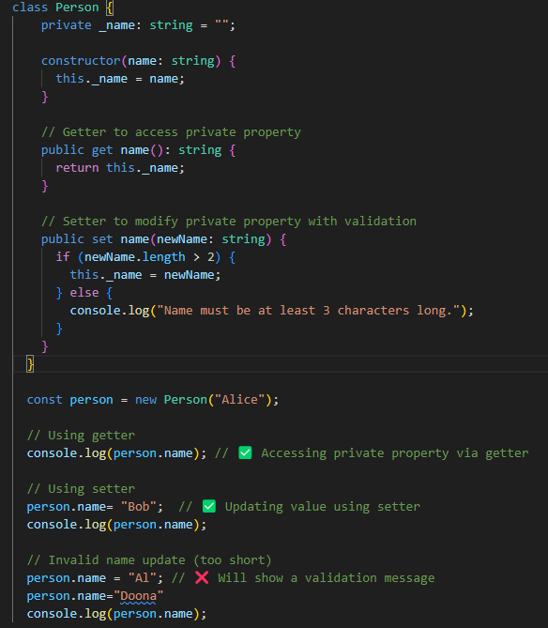

Abstract Class
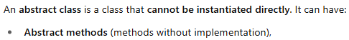
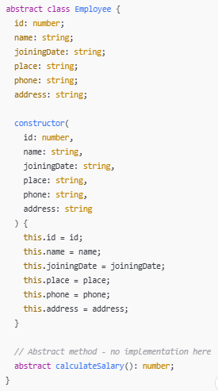

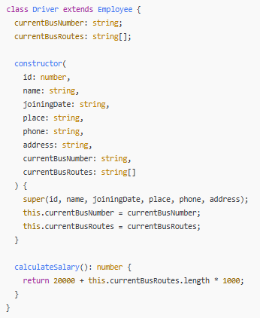
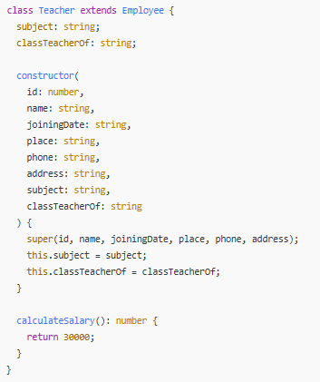

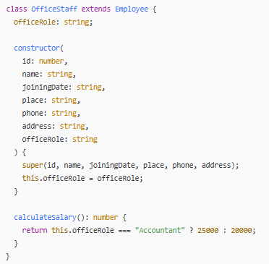
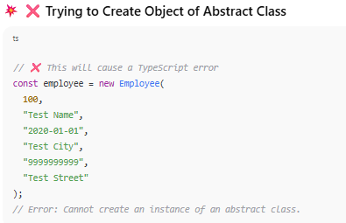
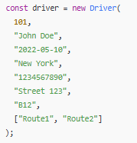
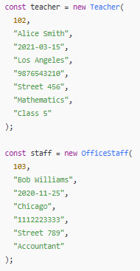
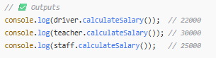
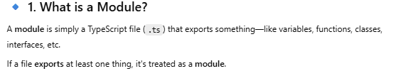
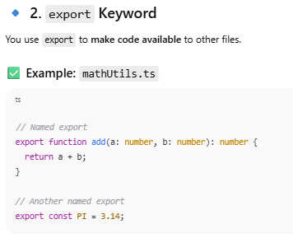
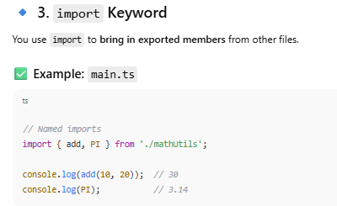
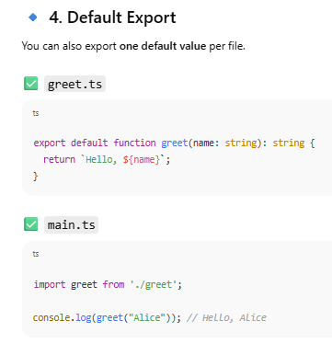
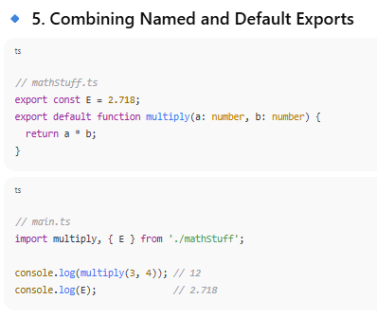
Enum in TypeScript

Enum (short for enumeration) is a special data type in TypeScript.
- It allows you to define a set of named constants, which can be either numeric or string-based.
- In simple terms, an Enum is a way to group related values together and assign them meaningful names instead of using plain numbers or strings.
Why Use Enums?
✅ Groups related values – Keeps code organized.
✅ Makes code readable – Easier to understand.
✅ Prevents mistakes – Only allows valid values.
✅ Removes hardcoding – No need to remember values.
✅ Reduces errors – Avoids typos and wrong inputs.
Types of Enums in TypeScript
1. Numeric Enums (Default)
By default, enums in TypeScript are assigned numeric values starting from 0 and incrementing by 1.
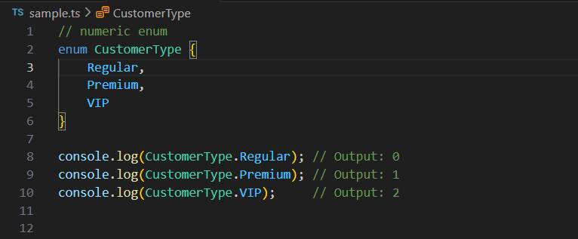

2. String Enums
Instead of numbers, you can assign string values to each member.


